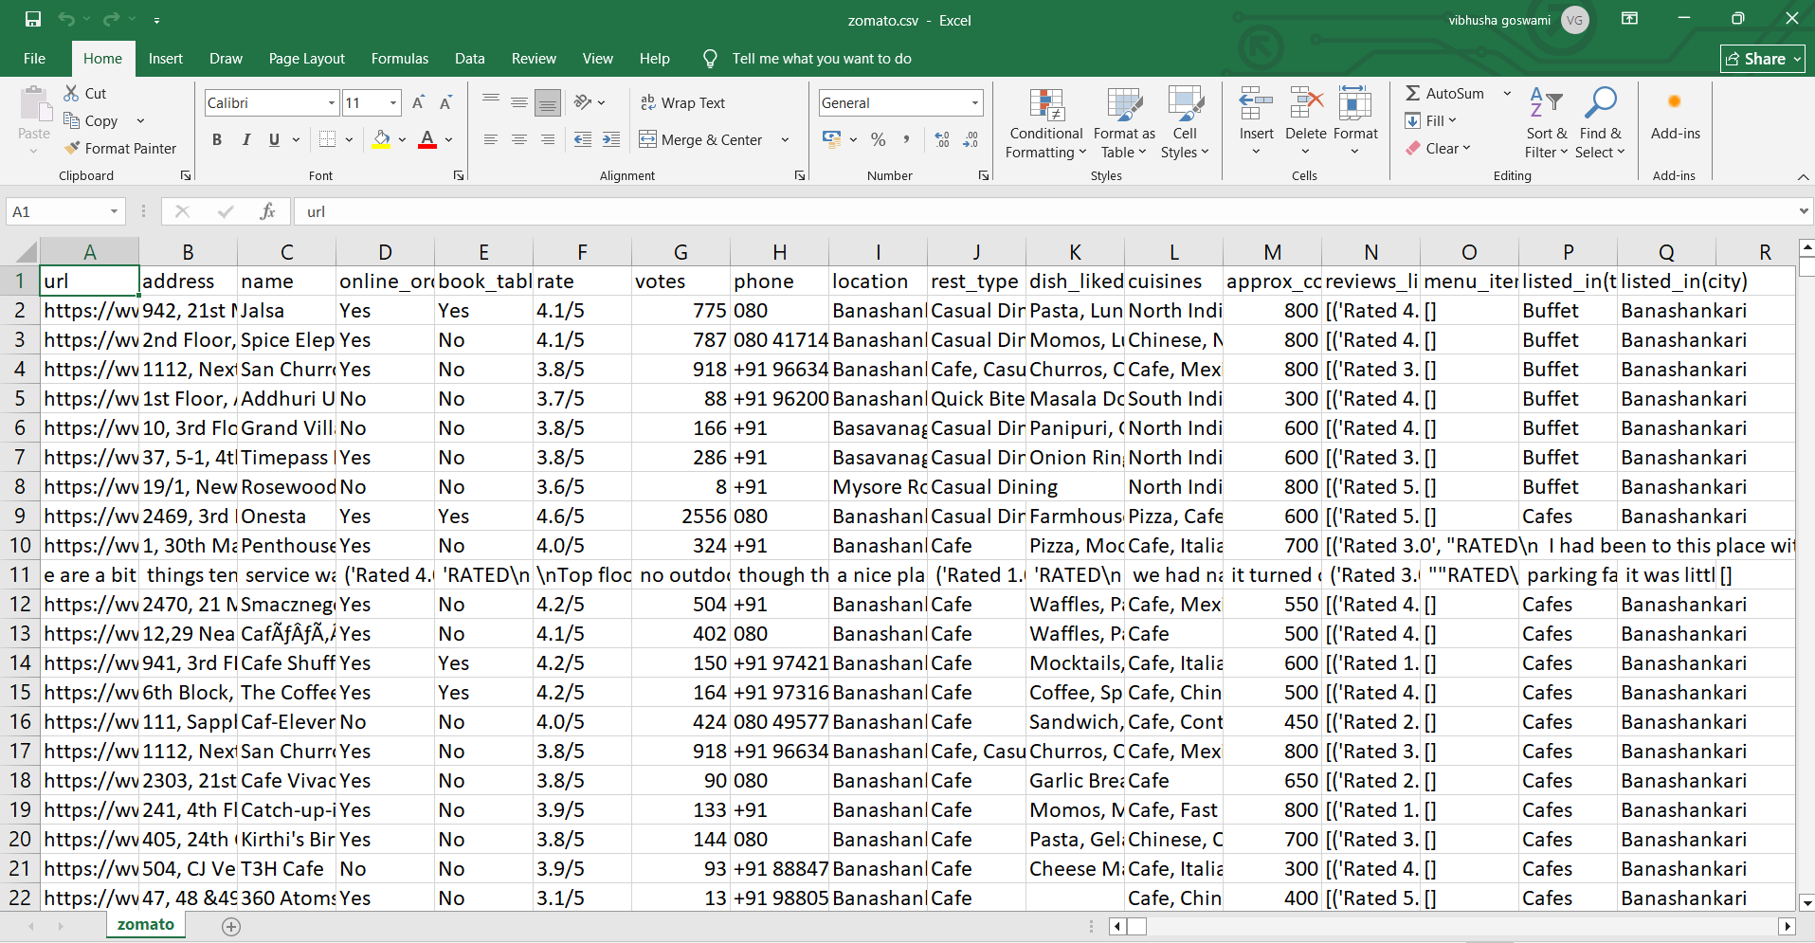
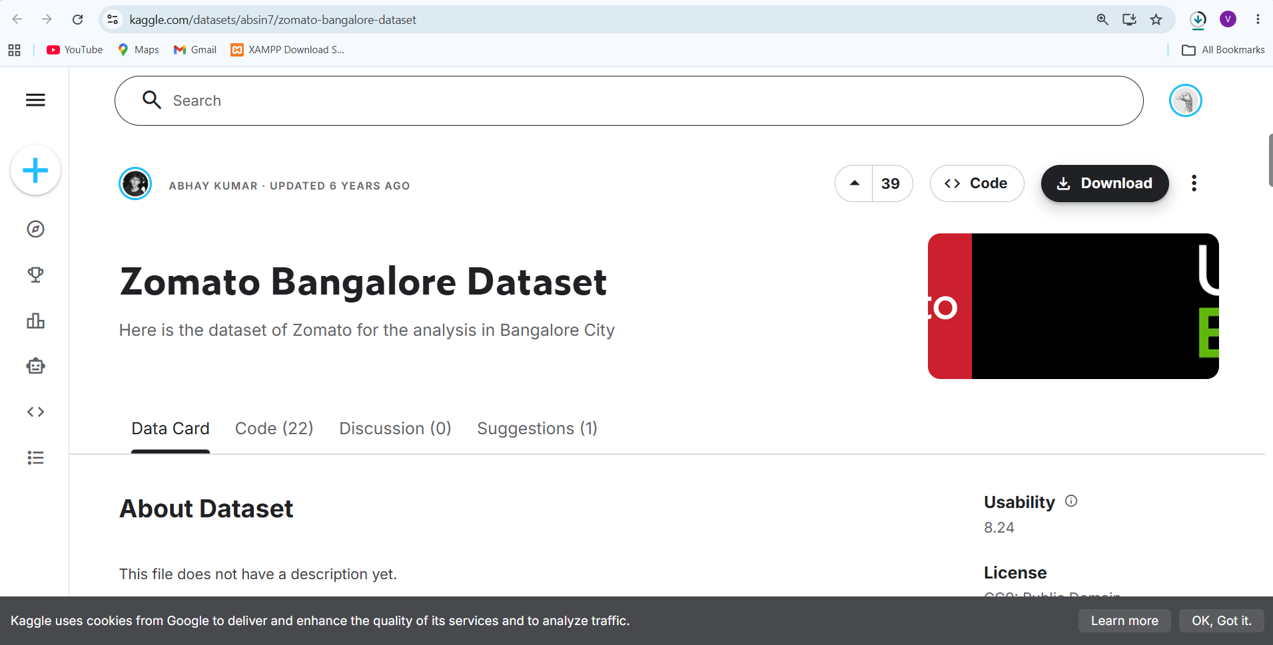
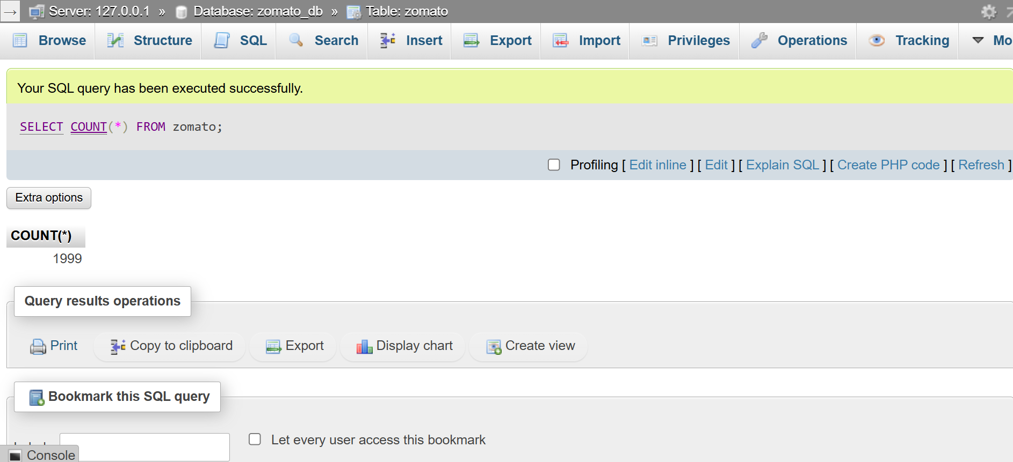
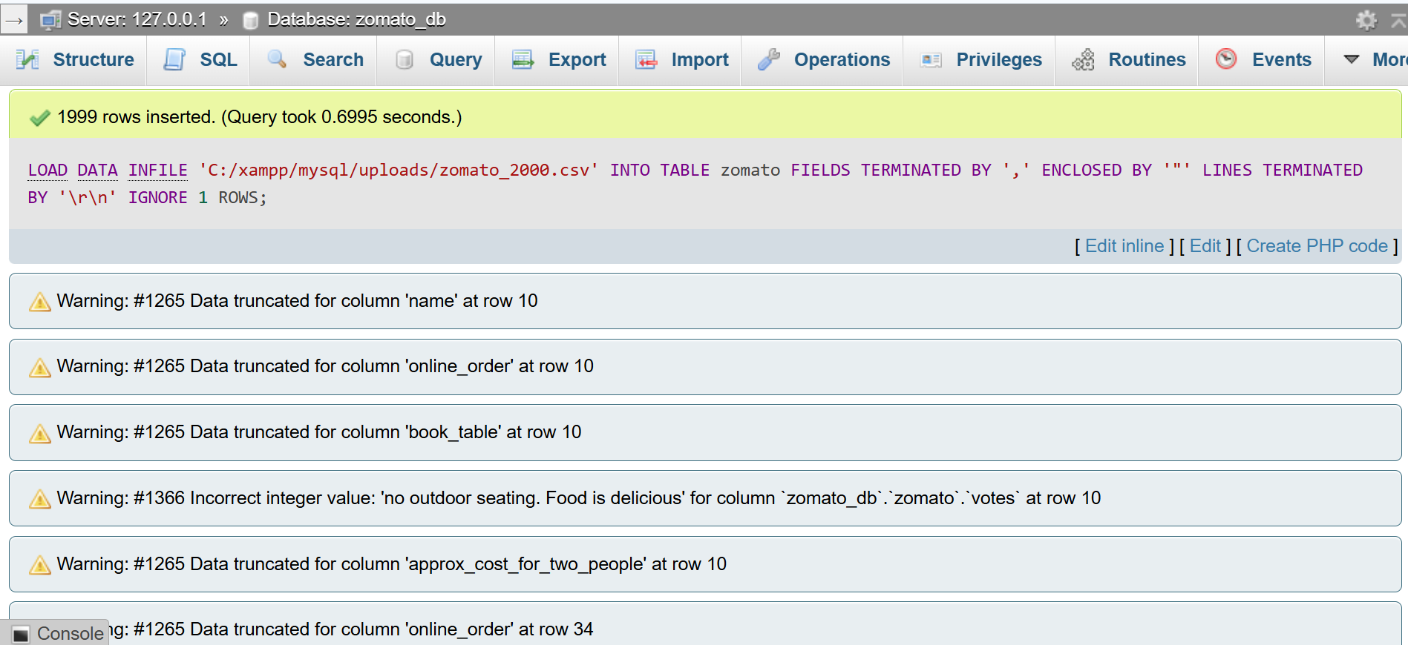

TABLE zomato :

CREATE TABLE zomato (
url TEXT,
address TEXT,
name VARCHAR(255),
online_order VARCHAR(10),
book_table VARCHAR(10),
rate VARCHAR(20),
votes INT,
phone TEXT,
location VARCHAR(100),
rest_type TEXT,
dish_liked LONGTEXT,
cuisines TEXT,
approx_cost_for_two_people VARCHAR(50),
reviews_list LONGTEXT,
menu_item LONGTEXT,
listed_in_type VARCHAR(100),
listed_in_city VARCHAR(100)
);

LOAD DATA INFILE 'C:/xampp/mysql/uploads/zomato.csv'
INTO TABLE zomato
FIELDS TERMINATED BY ','
ENCLOSED BY '"'
LINES TERMINATED BY '\n'
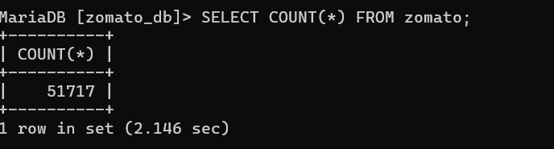
IGNORE 1 ROWS;

QUESTION : 1
Write an SQL query to find the top 5 highest-rated restaurants in Koramangala that serve North Indian cuisine, using the Zomato Bangalore dataset :

SELECT DISTINCT name,location,cuisines,rate,votes
FROM zomato
WHERE location LIKE '%Koramangala%'
AND cuisines LIKE '%North Indian%'
AND rate NOT IN ('NEW','-')
ORDER BY CAST(REPLACE(rate,'/5','') AS DECIMAL(3,1)) DESC,
votes DESC
LIMIT 5;

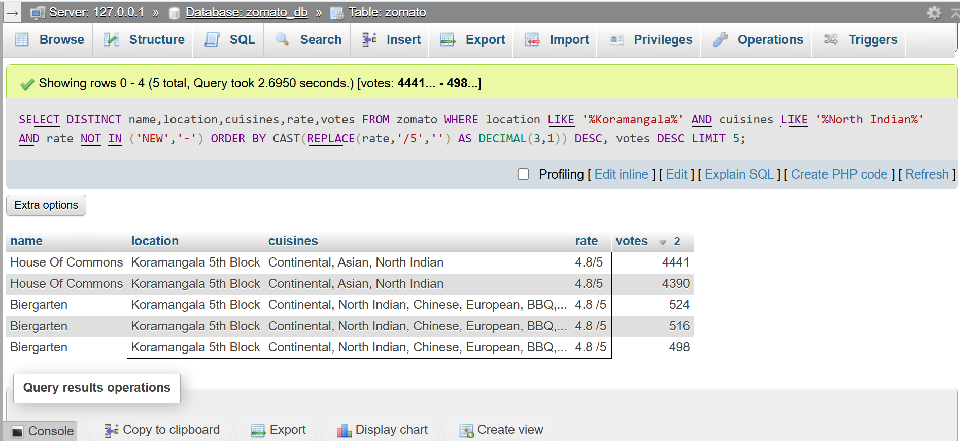
QUESTION : 2
Using SQL, calculate the average cost for two people for each cuisine type and list the 3 most expensive cuisines to eat in Bangalore :

SELECT
cuisines,
AVG(CAST(approx_cost_for_two_people AS UNSIGNED)) AS avg_cost
FROM zomato
WHERE approx_cost_for_two_people IS NOT NULL
GROUP BY cuisines ORDER BY avg_cost DESC LIMIT 3;

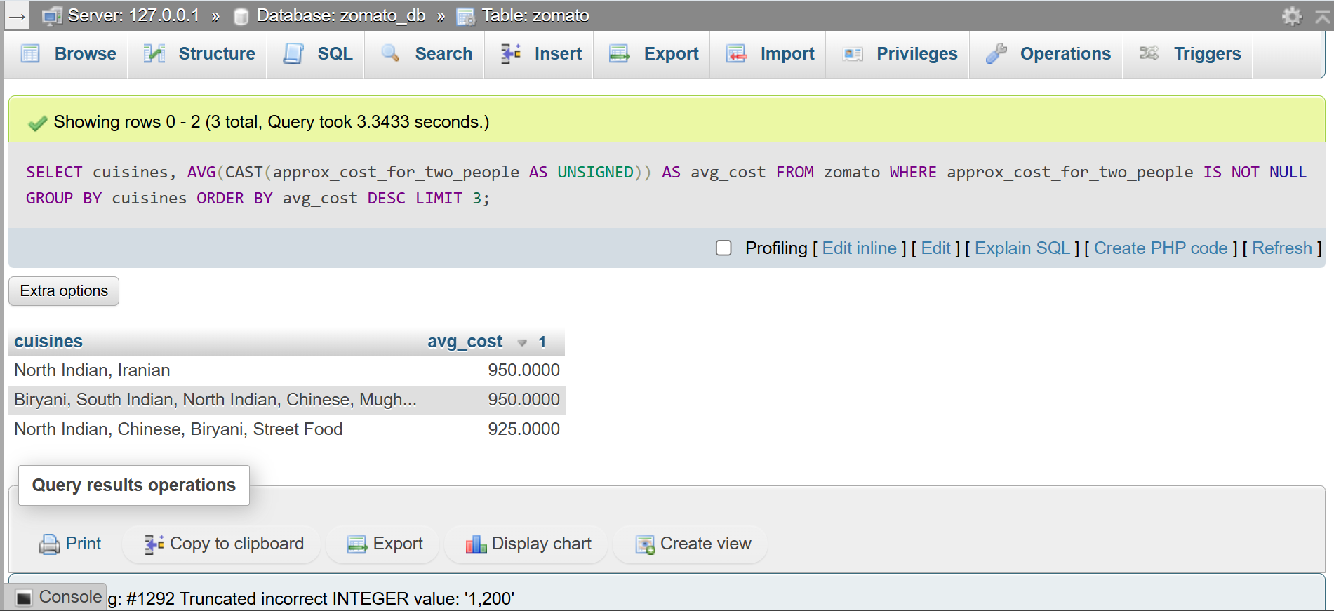
QUESTION : 3
Find all restaurants that offer online delivery but have a rating below 3.0, and suggest a marketing strategy to improve their ratings based on your findings.<br><br><em><strong>Hint:</strong> Look for patterns in location, cuisine, or price that might explain the low ratings.</em> :

SELECT name,location,cuisines,rate,votes
FROM zomato
WHERE online_order = 'Yes'
AND rate NOT IN ('NEW','-')
AND CAST(REPLACE(rate,'/5','') AS DECIMAL(3,1)) < 3.0 ;

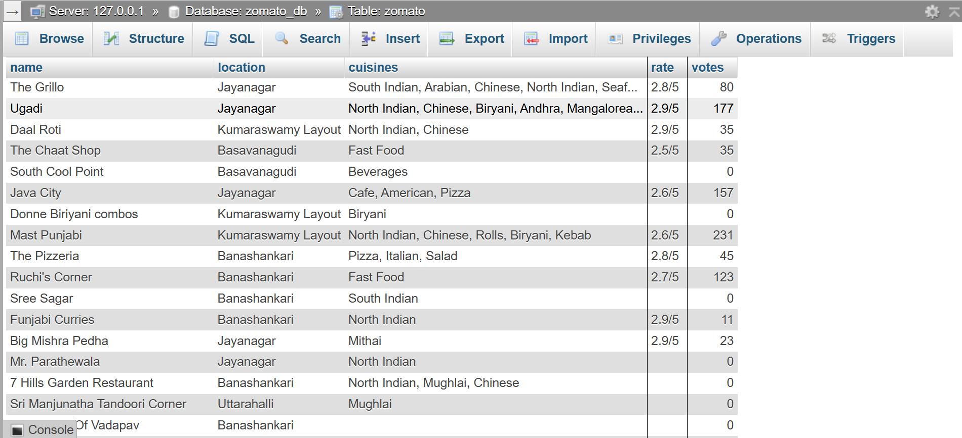
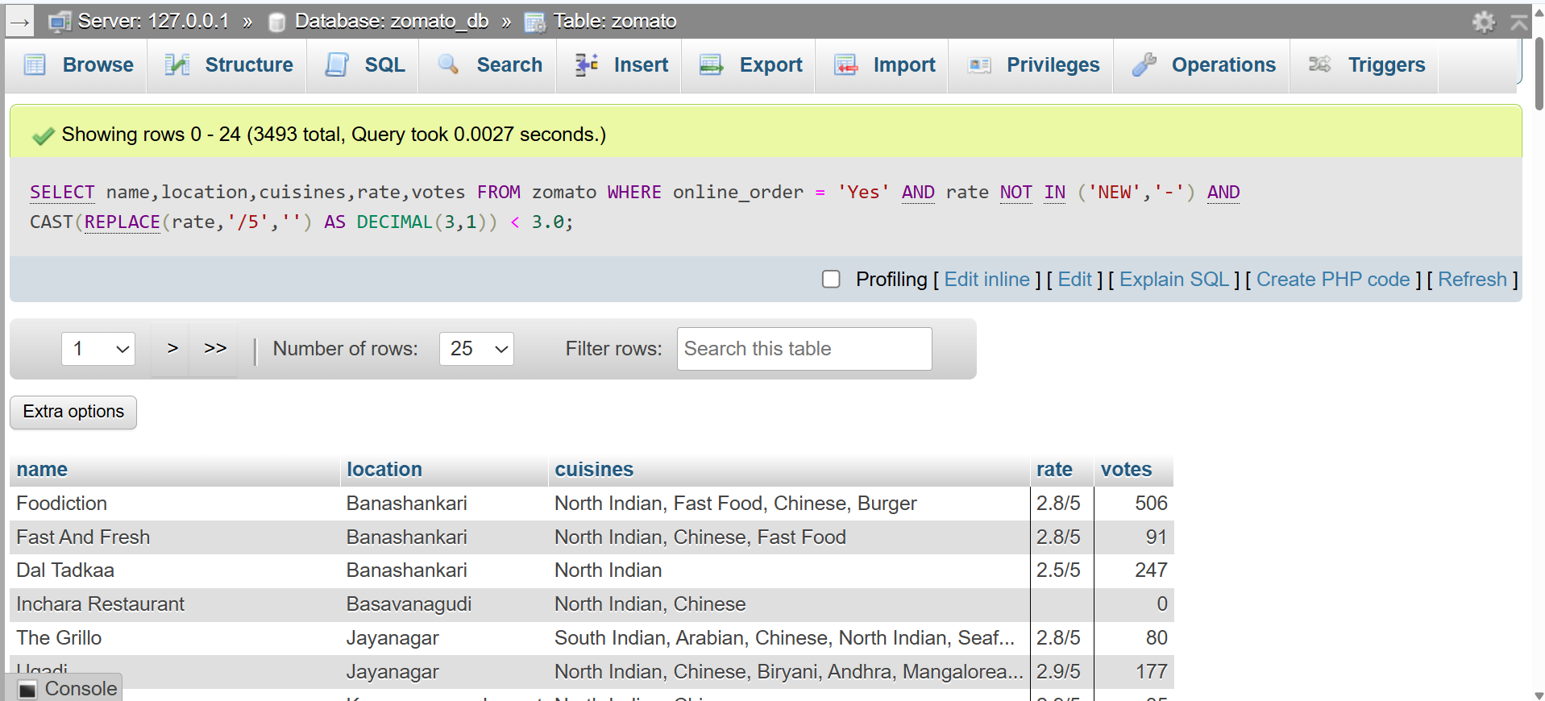
QUESTION : 4
Write an SQL query to segment restaurants into three market segments based on average cost for two: budget (below 400), mid-range (400-800), and premium (above 800). Count how many restaurants fall into each segment :

SELECT
CASE
WHEN CAST(approx_cost_for_two_people AS UNSIGNED) < 400
THEN 'Budget'
WHEN CAST(approx_cost_for_two_people AS UNSIGNED) BETWEEN 400 AND 800
THEN 'Mid-Range'
ELSE 'Premium'
END AS market_segment,
COUNT(*) AS restaurant_count
FROM zomato
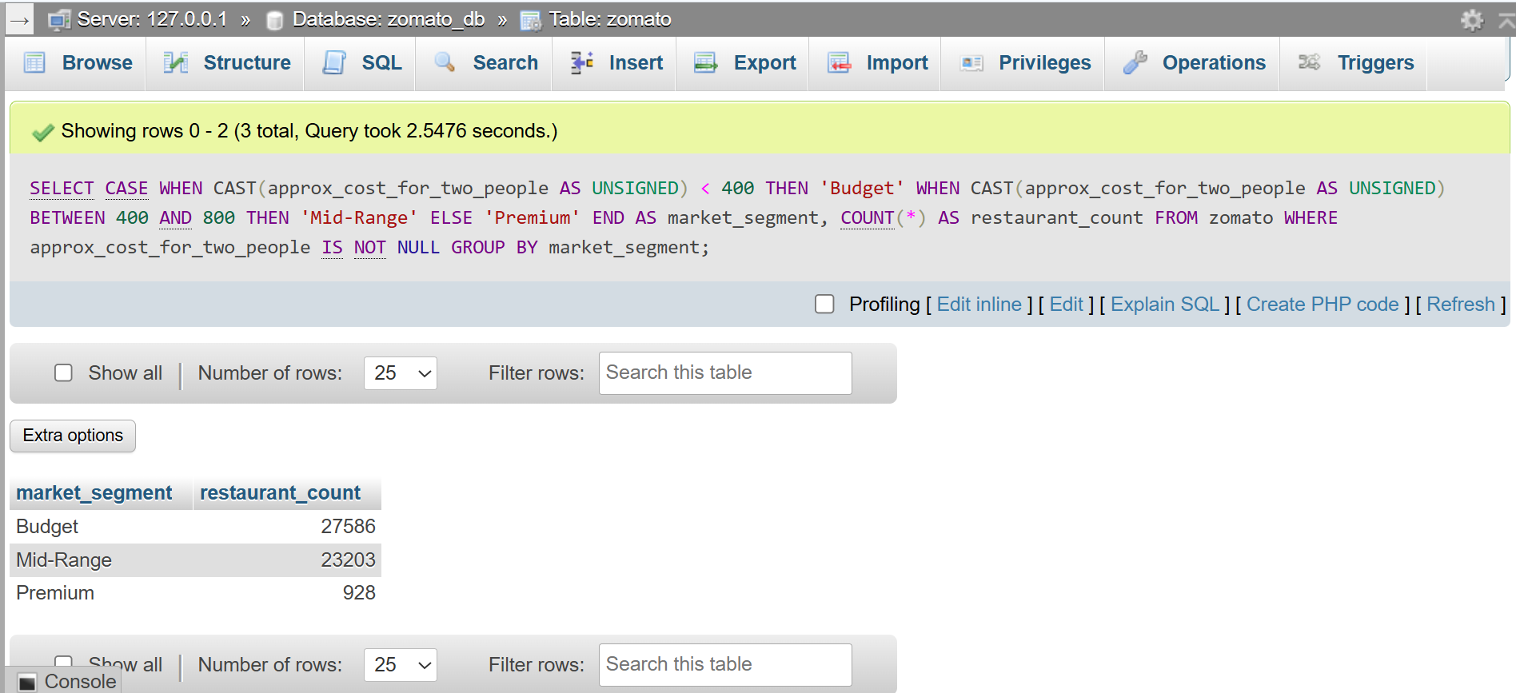
WHERE approx_cost_for_two_people IS NOT NULL GROUP BY market_segment ;
QUESTION : 5
Use ChatGPT or Copilot to help you write an SQL query that lists the top 10 most popular restaurant chains (by number of outlets) in the dataset, then run and validate the query yourself.<br><br><em><strong>Hint:</strong> Search for 'SQL group by count example' if you get stuck.</em> :

SELECT name,
COUNT(*) AS outlet_count
FROM zomato
GROUP BY name
ORDER BY outlet_count DESC LIMIT 10 ;
